Pima Datacenter Firewall Project
Cybersecurity Portfolio Project – Macario Givens
Pima Community College
Proxmox | Palo Alto NGFW | GlobalProtect VPN | Zone-Based Segmentation

1. Project Overview
For my capstone project, we designed and deployed a secure virtual network using a Palo Alto Next-Generation Firewall (NGFW). The goal was to simulate a small company environment and configure a firewall that could monitor network traffic, enforce access controls, and support secure remote administration.

To accomplish this, we built several virtual machines in Proxmox, installed and configured the Palo Alto firewall, and set up key network components such as Trust, Untrust, and DMZ zones. We also configured routing, NAT policies, and VPN access for remote management.

We considered the project successful once the network achieved full inbound and outbound connectivity, demonstrated proper segmentation through its zone design, and allowed reliable remote access.

Another major objective was to strengthen my understanding of how firewalls are deployed and managed in real-world environments. We approached the work as if we were creating an actual corporate network, complete with security policies, documentation, and troubleshooting methods. Success meant more than just a working firewall — it meant being able to clearly explain the reasoning behind each configuration choice and the security benefits it provided.

2. Research and Methodology
Our research focused on understanding Palo Alto Firewalls, including their GUI configuration interface, routing protocols, NAT configuration, and VPN capabilities. We also researched how Palo Alto NGFWs classify traffic using applications, users, ports, and threat prevention signatures, allowing more precise policy enforcement than traditional firewalls.

Technologies and tools included:
- Palo Alto NGFW for firewall functionality
- Proxmox virtualization to host the Ubuntu and Windows VMs
- Ubuntu Desktop as one of the primary internal hosts
- GlobalProtect VPN for remote access to the firewall
- Switches and physical hardware provided in the Pima Data Center
- Palo Alto CLI + GUI for management tasks

Research also included guidance from a Data Center advisor, Palo Alto documentation, and trial-and-error testing as we diagnosed routing, NAT, and remote access issues.

3. Design and Development Process
The development process unfolded in progressive stages:

A. Planning, Environment Setup and Network Topology
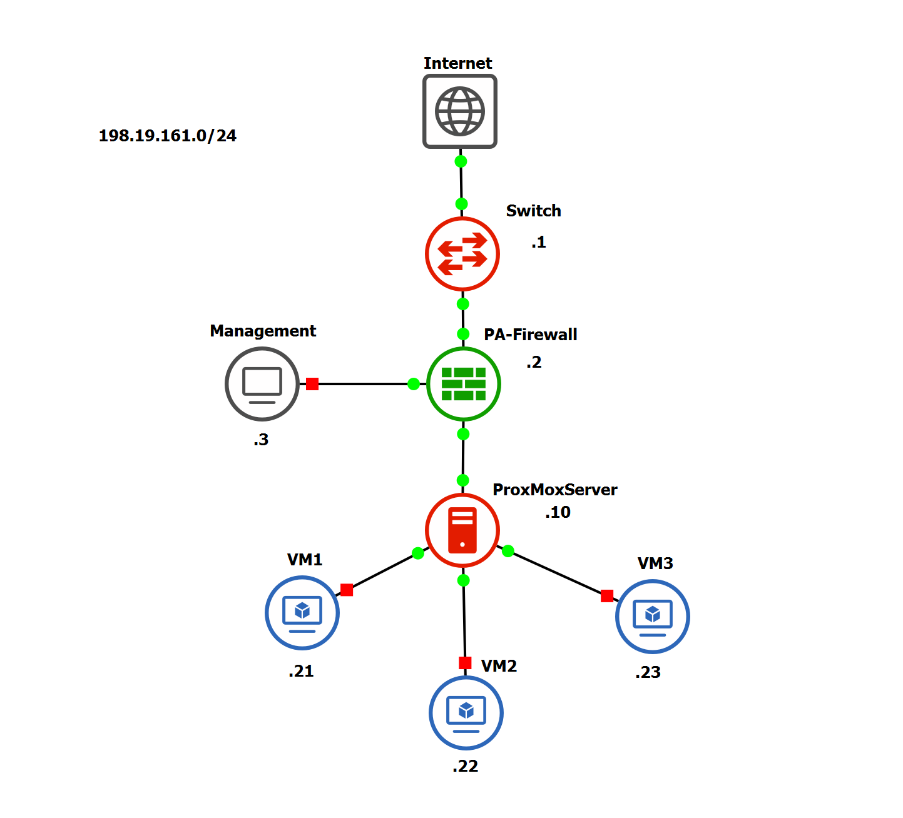

During the initial environment setup, we configured the core switch and hypervisor used in the lab. The switch was assigned a management VLAN IP, default gateway, and DNS settings. Remote access to the switch and Proxmox server was secured with lab credentials.

Security Note: All credentials and internal IP addresses used in this lab have been redacted from this portfolio version. In a real environment, default credentials should always be changed immediately upon deployment.

The project started with understanding the deliverables and selecting the correct hardware and virtualization platform. Tasks included acquiring a switch, installing Proxmox, and building the first virtual machines. We struggled initially with finding the correct login credentials for the newly installed Proxmox environment and connecting the server to the internet, but resolved these issues through team collaboration and reinstalling Proxmox from the Data Center's thumb drive.

B. Firewall Installation & Access
After Proxmox was functional, we successfully installed the Palo Alto Firewall. Initially, access to the firewall GUI was only possible via physical connection, which led us to examine our routing protocols and reconsider how the firewall fit into our network topology.

C. Routing, NAT, and Policy Configuration
For routing and NAT design, we standardized on a /24 IP network for most internal systems and documented an additional range for future expansion and testing. These networks were used to outline the internal segments that the virtual router and firewall policies would control.

Through research and guidance from our Data Center advisor, we learned how to compare routing tables and establish the policies required for full connectivity. This included configuring virtual routers, assigning zone interfaces, and defining basic security rules. A major milestone was successfully routing traffic from the internal network out through the firewall to the internet. Site-to-site and remote access configuration was later added using GlobalProtect VPN, enabling remote management from home.

D. Remote Management & Virtual Router Modifications
Within Proxmox, we deployed two primary Ubuntu-based VMs used to test connectivity and security policies. These hosts acted as internal clients for verifying routing, NAT, and zone-based security rules.

The Palo Alto firewall was managed using a dedicated management IP address, with admin access provided via secured credentials. Once routing and virtual router settings were in place, we were able to reach this management interface over the network using both the web GUI and SSH for remote administration. We created a virtual router, updated Proxmox to match the new IP range, and enabled SSH access to the Palo Alto CLI, allowing full remote administration.

E. Testing and Iteration
Throughout the project, we conducted continuous testing to verify that each part of the network functioned as intended. This included checking connectivity between virtual machines, validating GUI and CLI access to the Palo Alto firewall, and confirming that both internal and remote devices could reach the internet through the configured policies and NAT rules.

We repeatedly tested routing behavior, firewall rule enforcement, and GlobalProtect VPN access, adjusting configurations whenever inconsistencies appeared. These testing cycles were necessary not only for troubleshooting but also for refining our understanding of how traffic flowed through the network. Each round of testing strengthened the reliability of the environment and ensured configuration aligned with project goals.

4. Results and Achievements
Throughout the project, our team accomplished several major milestones demonstrating successful implementation of the Palo Alto firewall and company environment:

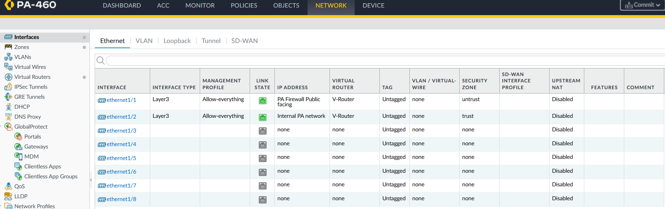
Interfaces
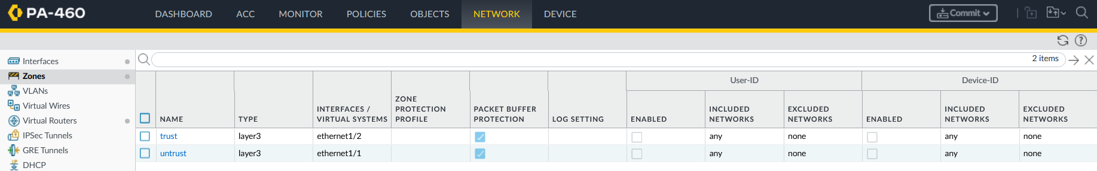
Zones
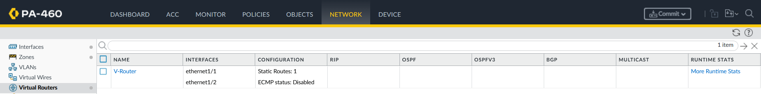
Virtual Routers
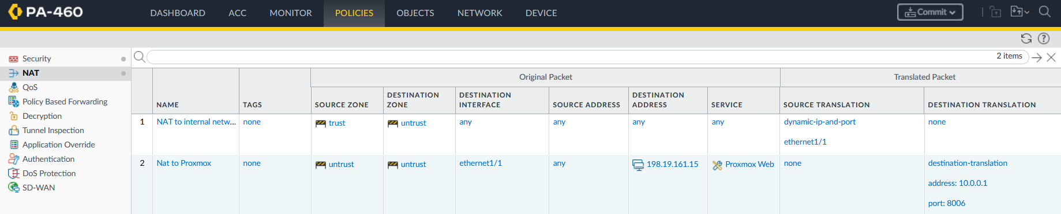
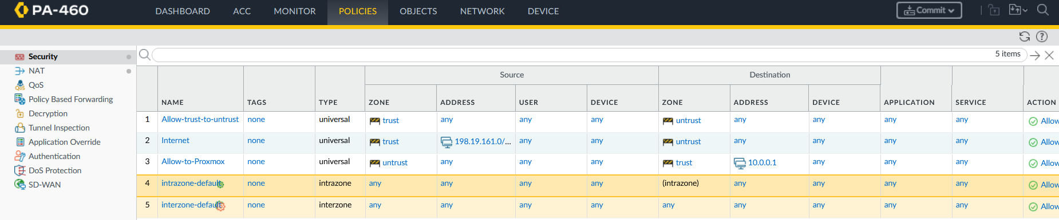
Security Policies and NAT Rules
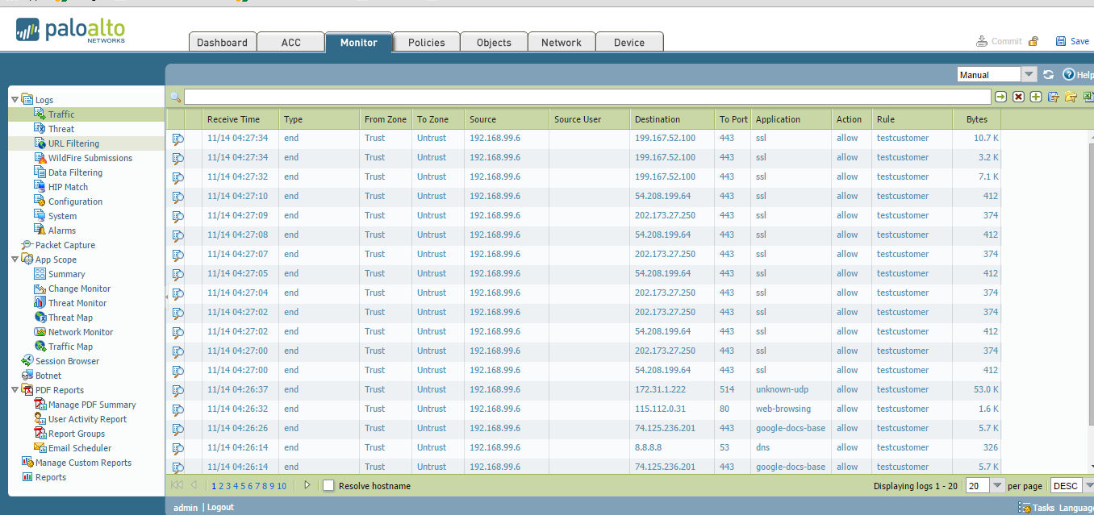
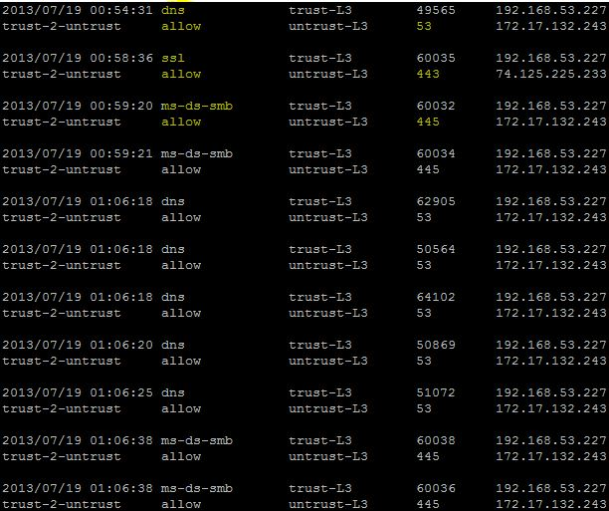
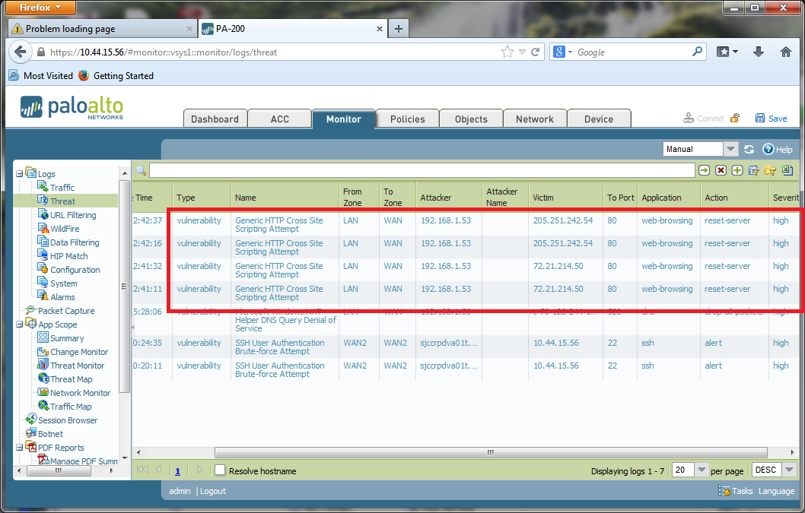
Monitoring through the PA GUI/CLI, Threat Logs, and URL Filtering
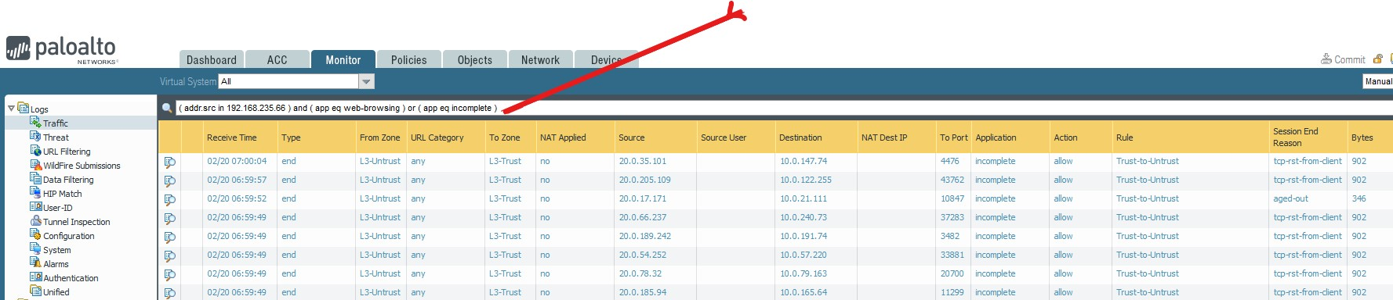
Traffic Logs

Key Outcomes:
- Successfully installed and configured Proxmox with multiple VMs
- Installed and configured the Palo Alto Firewall
- Created Trust, Untrust, and internal routing zones
- Configured routing protocols and policies to enable internet access through the firewall
- Enabled GlobalProtect remote access, allowing management from home
- Configured a virtual router with a new IP scheme and updated Proxmox to match it
- Successfully accessed the firewall GUI and CLI remotely

While most objectives were met successfully, the only pending issue involved a suspected hardware-related NAT routing problem that interfered with accessing the Proxmox GUI on port 8006.

5. Challenges and Problem-Solving
Throughout the project, we encountered several technical and non-technical challenges that required persistent troubleshooting and collaboration.

One of the first obstacles involved identifying the correct Proxmox login credentials, which slowed initial progress until resolved through team communication and trial-and-error. We also dealt with early connectivity problems, including difficulty establishing internet access for the server and being unable to reach the firewall's interface except through a direct physical connection.

As we progressed, misconfigured routing tables and incomplete NAT rules caused additional setbacks, requiring us to revisit our network plan and seek guidance from our Data Center advisor. One of the largest challenges occurred later in the project when a suspected hardware issue caused NAT routing failures that prevented access to the Proxmox GUI via port 8006.

Non-technical difficulties also played a role, such as balancing coursework from multiple classes, coordinating schedules within the team, and adapting to the project's evolving scope. Despite these issues, we overcame each challenge through a positive mindset, research, and teamwork, ultimately gaining a deeper understanding of firewall configuration and network infrastructure.

6. Future Work and Recommendations
There are several opportunities to expand and enhance the work completed in this project:

- Fully resolve the NAT routing issue that prevented remote access to Proxmox, which may require additional hardware testing or replacing a faulty component
- Implement advanced security profiles such as URL filtering, antivirus scanning, threat prevention, and application-layer policies
- Add a dedicated DHCP server to automate IP assignments
- Add a DMZ hosting a web server to simulate external-facing services
- Create automation scripts to back up firewall configurations and export logs on a regular schedule
- Integrate firewall logs into a SIEM platform to improve monitoring, alerting, and threat analysis
- Improve documentation with screenshots captured throughout the configuration process to make the environment easier to replicate and maintain

All of these enhancements would turn the environment into a more complete enterprise-level security lab.

7. Reflection
This project significantly improved my understanding of firewall deployment, networking, and troubleshooting. We learned how to work with enterprise-level tools such as Proxmox, Palo Alto NGFWs, and GlobalProtect, and gained hands-on experience configuring routing, NAT, and policy enforcement. I also learned the importance of thorough documentation, collaboration, and iterative problem-solving.

If we were to start over, we would:
- Document each step more consistently from the beginning
- Spend more time early on learning routing fundamentals
- Test hardware earlier to avoid late-stage setbacks

Overall, this project has been a valuable experience in networking and firewall deployment. I learned a lot across different areas of IT and genuinely enjoyed working on it with my teammates. Even with all the issues we ran into, we pushed through and made everything work to the best of our abilities.

References
https://docs.paloaltonetworks.com/ngfw/getting-started/initial-setup-configuration-ngfws/network-access-for-external-services
https://docs.paloaltonetworks.com/ngfw/networking/configure-service-routes

Virtual Router
https://docs.paloaltonetworks.com/pan-os/11-0/pan-os-networking-admin/virtual-routers/virtual-router-overview
https://docs.paloaltonetworks.com/ngfw/networking/configure-virtual-routers

Trust and Untrust Zones
https://docs.paloaltonetworks.com/ngfw/getting-started/initial-setup-configuration-ngfws/segment-your-network/configure-interfaces-and-zones
https://docs.paloaltonetworks.com/network-security/security-policy/administration/security-rules/create-a-security-policy-rule

Policies for Zones
https://docs.paloaltonetworks.com/network-security/security-policy/administration/security-policy

